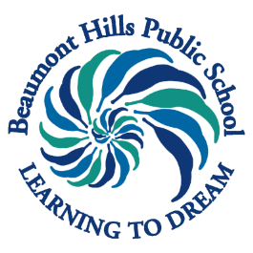
Beaumont Hills Public School
The Parkway, Beaumont Hills NSW 2155

(e) beaumonthi-p.school@det.nsw.edu.au (w) beaumonthi-p.schools.nsw.gov.au (p) 8824 6470 (f) 8824 6473

12 February, 2019

ACTIVITIES INVOLVING FOOD

Dear Parent/Caregivers,

From time to time teachers plan activities involving food as a part of classroom learning activities. These activities provide students with valuable hands on experiences that act as stimulus to in class writing, discussion or response activities. At times students are also able to eat what has been made. This will always occur in class under teacher supervision.

Please complete the permission form below, noting any allergies that staff need to be aware of during these learning experiences to prevent allergic or anaphylactic reactions and to allow awareness of cultural beliefs. Please return the permission note no later than Friday 1 March, 2019.

Miss Tolsher Ms Welsh
Deputy Principal Principal
Please keep this section for your information
……..……………………………………………………………………..……………………………………………………………………….
Please return this section to the School Administration Office no later than Friday 1 March, 2019

BEAUMONT HILLS PUBLIC SCHOOL - ACTIVITIES INVOLVING FOOD

I give permission for my child……………………………….……..………………………..of year …….….
to be involved in class activities involving food. This excludes any activities that include the ingredients listed below.

Allergy alert please tick:

I confirm my child does not have any food allergies or cultural beliefs that prevent them from participating in class activities involving food.
I confirm my child does have food allergies or cultural beliefs that prevent them from participating in activities with the following ingredients (please list below):

………………..…………………………………………………………………………………………………
………………..…………………………………………………………………………………………………
I am aware that I need to inform the school if the information on this form changes at any time due to new diagnoses.

Signed: …………………..……………..…………….…..…………. Date: ………………….
(Parent/Caregiver)

